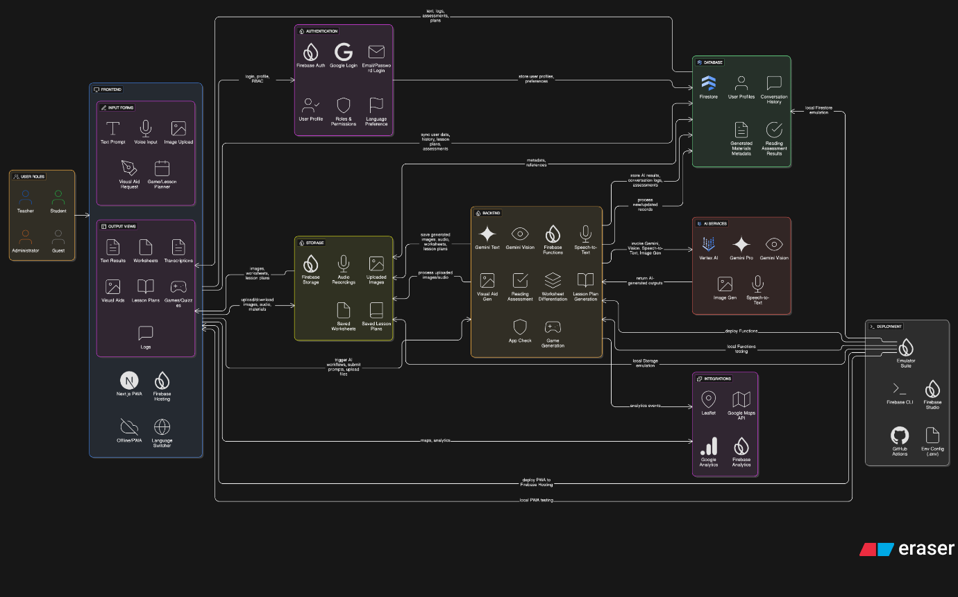

**Google Cloud Architecture for “Sahayak” AI Teaching Assistant**

**Frontend**

* **Firebase Hosting**
  + Next.js (PWA support for low-resource areas)
  + Language switcher (Hindi, Marathi, Tamil, etc.)
  + Inputs:
    - Text prompts (knowledge base questions)
    - Voice input (teacher requests, student reading)
    - Image upload (textbook pages for worksheets)
    - Visual Aid description (for line-drawing generation)
    - Game / lesson planner forms
  + Outputs:
    - Gemini text generation results
    - Differentiated worksheets
    - Transcriptions
    - Generated images
    - Games/quiz formats
    - Lesson plans
  + Conversation logs view

Features:

* Responsive design for mobile access
* Offline-ready with PWA install

**Authentication and User Management**

* **Firebase Auth**
  + Email/password or Google login
  + RBAC (teacher roles if needed)
  + User profile & language preference

**Storage**

* **Firebase Storage**
  + Audio recordings
  + Uploaded textbook images
  + Generated images (visual aids)
  + Saved worksheets / lesson plans

**Database**

* **Cloud Firestore**
  + User profiles
  + Conversation history
  + Saved lesson plans
  + Generated materials metadata
  + Student reading assessment results

Features:

* Offline sync support for low-bandwidth
* Structured queryable content

**Backend Processing / Cloud Functions**

* **Firebase Functions**
  + Secure server-side logic:
    - Speech-to-Text pipeline with Vertex AI
    - Gemini text generation
    - Gemini Vision image analysis
    - Image generation for visual aids
    - Reading assessment scoring
    - Worksheet differentiation prompts
    - Lesson plan generation
    - Educational game generation
  + App Check enforced for security

Benefits:

* Scalable, event-driven
* Can be tested with Emulator Suite

**AI Services**

* **Vertex AI**:
  + Gemini Pro / Gemini 1.5 for:
    - Text generation (knowledge base Q&A, lesson plans, games)
    - Differentiated worksheet generation
    - Multi-language content creation
  + Gemini Vision:
    - Textbook page image analysis
    - Worksheet generation from images
  + Vertex AI Speech-to-Text:
    - Teacher voice input transcription
    - Student reading assessment transcription
  + Vertex AI Image Generation (if available):
    - Simple blackboard-friendly line art generation

**Deployment / DevOps**

* **Firebase CLI + GitHub Actions (optional)**
  + Build, test, and deploy to Firebase Hosting & Functions
  + Use Emulator Suite for local development
  + Manage environment configs with .env files
* Firebase Studio for deployment interface

**Optional Integrations**

* Google Maps API or Leaflet for local map integration (if needed for lesson materials)
* Google Analytics / Firebase Analytics for usage tracking

**Frontend**

* Firebase Hosting / Next.js (PWA)
* Input forms (text, voice, image, planning)
* Output views (cards/lists, worksheets, games, plans)

**Auth**

* Firebase Auth

**Storage**

* Firebase Storage (images/audio/materials)

**Database**

* Firestore (user data, history, assessments)

**Backend**

* Firebase Functions
  + Speech-to-Text (Vertex AI)
  + Gemini text generation
  + Gemini Vision
  + Reading assessment
  + Image generation for visual aids

**AI Services**

* Vertex AI
  + Gemini Pro
  + Gemini Vision
  + Speech-to-Text

**Deployment**

* Firebase CLI, Emulator Suite
* Firebase Studio, GitHub Actions